**2.1.1 Creating ndarray**

In[1]:

code

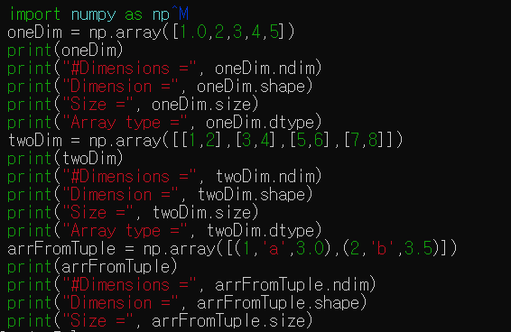

Result:

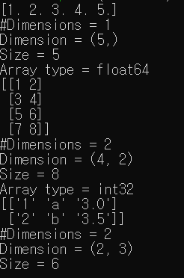

In[2]

Code:

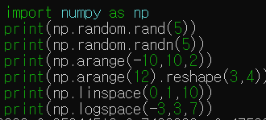

Result:

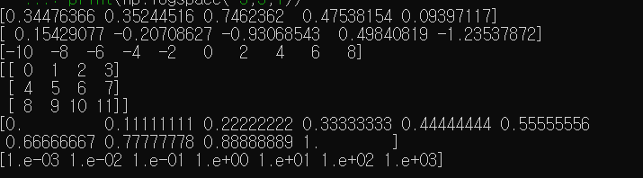

In[3]

Code:

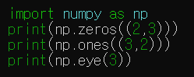

Result:

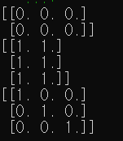

**2.1.2 Element-wise Operations**

In[4]

Code:

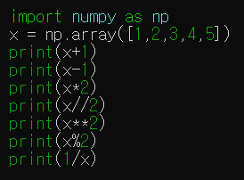

Result:

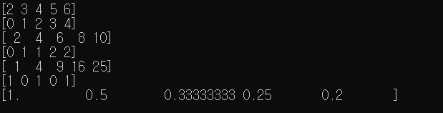

In[5]

Code:

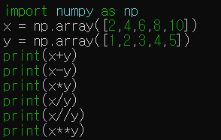

Result:

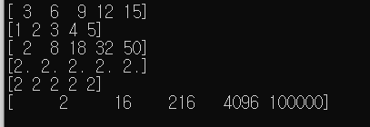

**2.1.3 Indexing and Slicing**

In[6]:

Code:

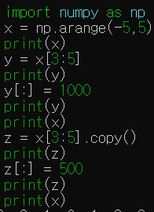

Result:

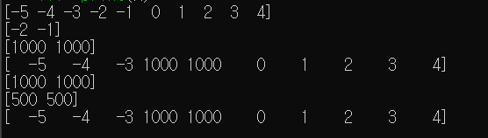

In[7]

Code:

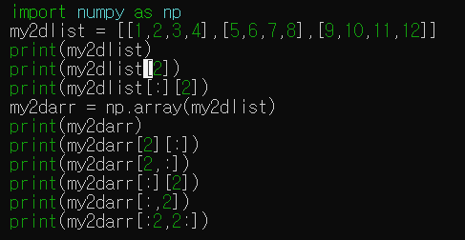

Result:

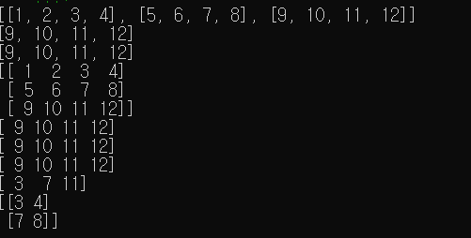

In[8]:

Code:

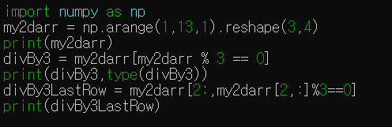

Result:

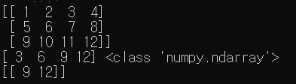

In[9]:

Code:

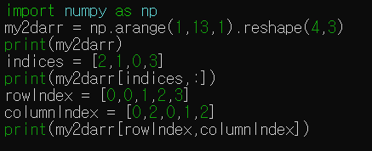

Result:

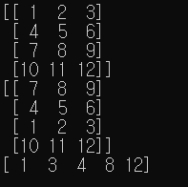

**2.1.4 Numpy Arithmetic and Statistical Functions**

In[10]

Code:

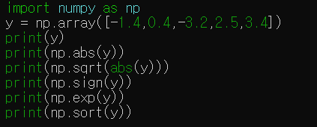

Result:

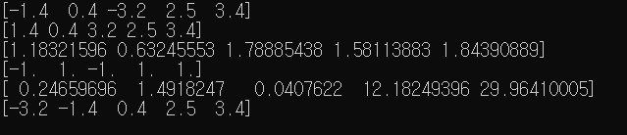

In[11]

Code:

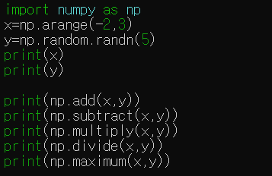

Result:

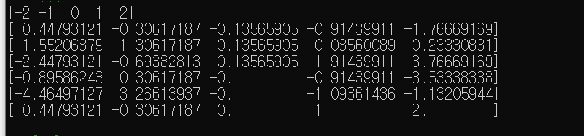

In[12]:

Code:

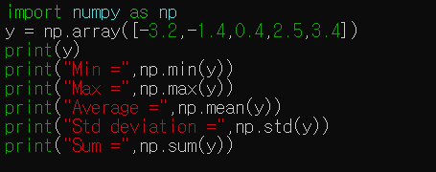

Result:

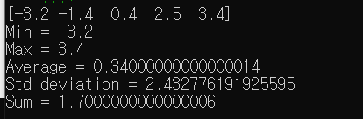

**2.1.5 Numpy linear algebra**

In[13]

Code:

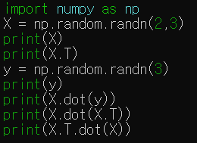

Result:

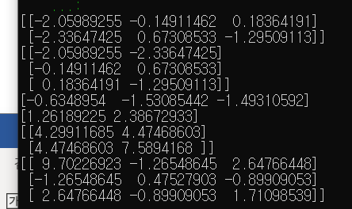

In[14]

Code:

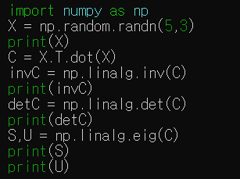

Result:

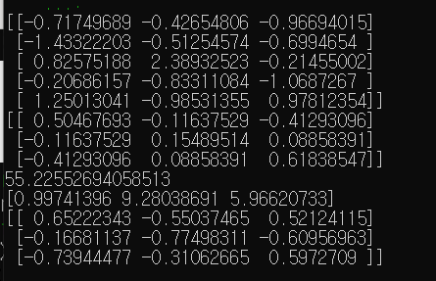

**2.2.1 Series**

In[15]:

Code:

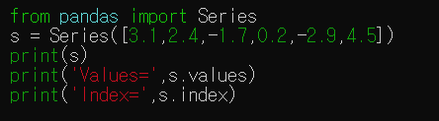

Result:

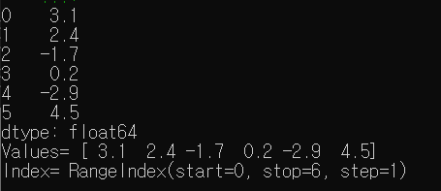

In[16]

Code:

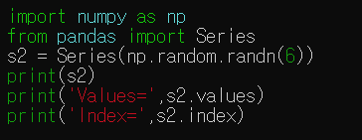

Result:

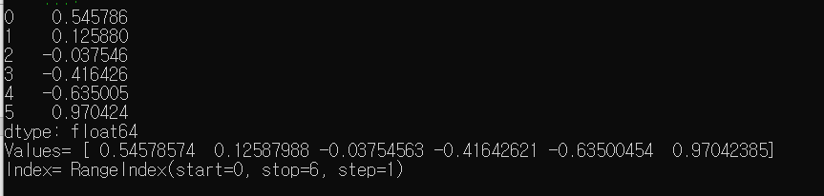

In[17]

Code:

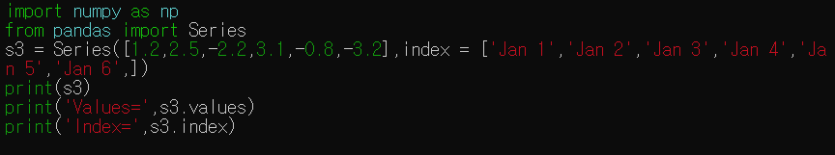

Result:

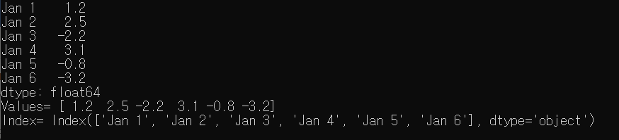

In[18]

Code:

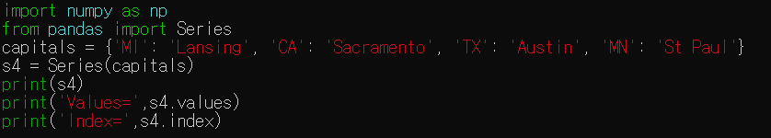

Result:

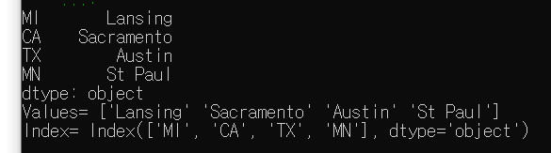

In[19]

Code:

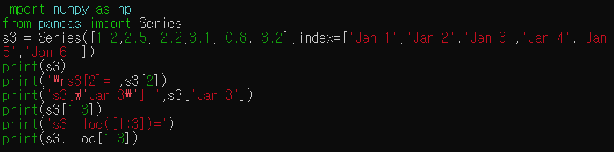

Result:

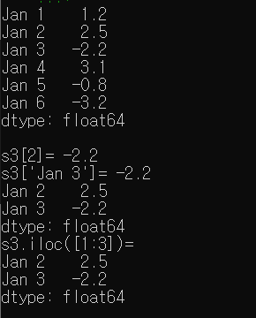

In[20]

Code:



Result:



In[21]

Code:



Result:

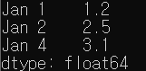

In[22]

Code:

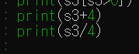

Result:

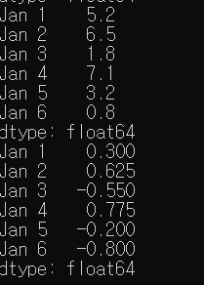

In[23]

Code:



Result:

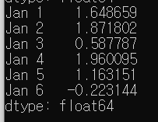

**2.2.2 DataFrame**

In[24]

Code:

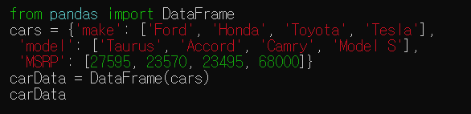

Result:

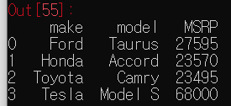

In[25]

Code:

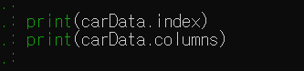

Result:



In[26]

Code:

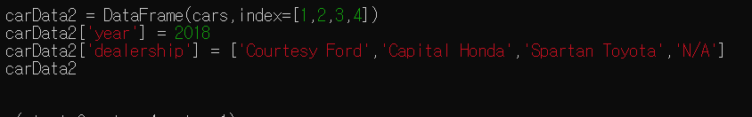

Result:

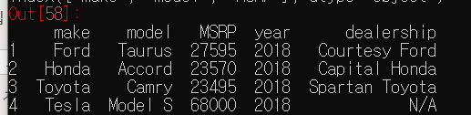

In[27]

Code:

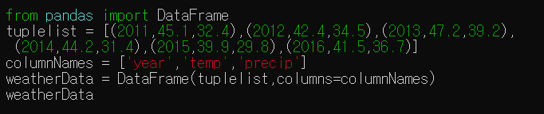

Result:

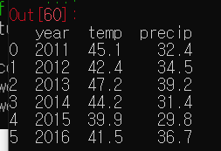

In[28]

Code:

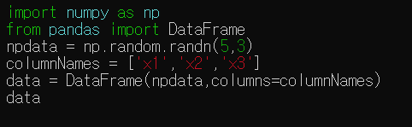

Result:

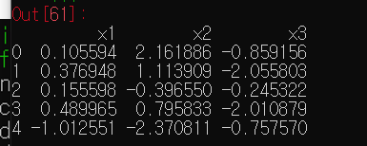

In[29]

Code:

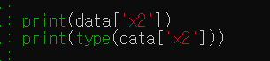

Result:

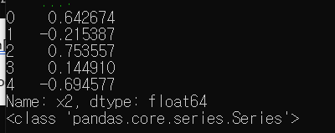

In[30]

Code:

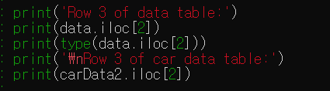

Result:

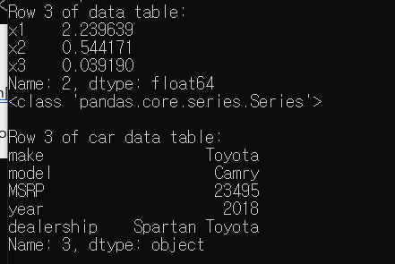

In[31]

Code:

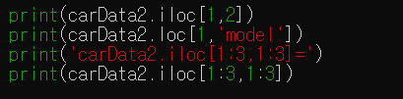

Result:

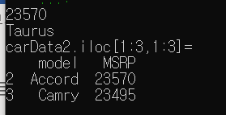

In[32]

Code:



Result:



In[33]

Code:

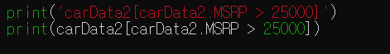

Result:

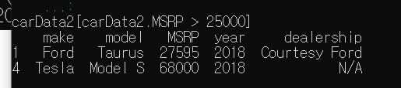

**2.2.3 Arithmetic Operations**

In[34]

Code:

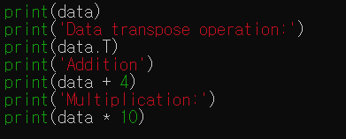

Result:

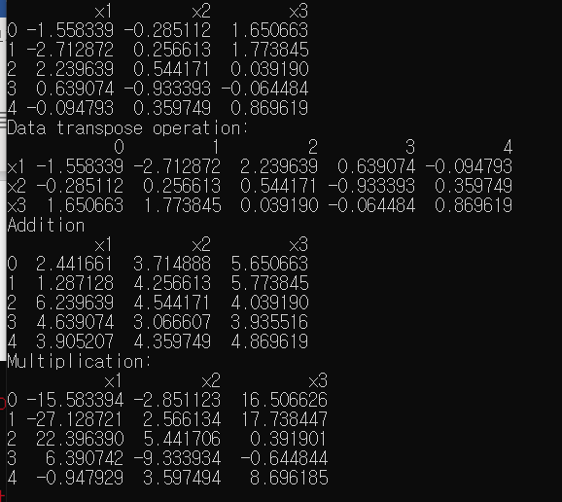

In[35]

Code:

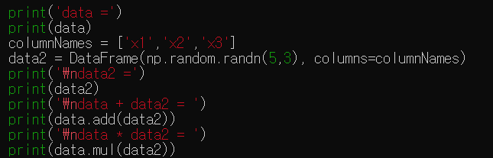

Result:

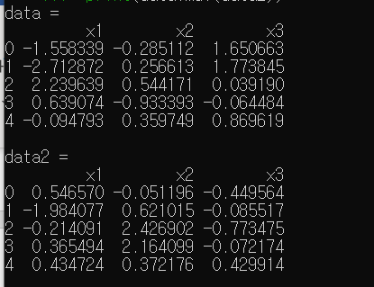

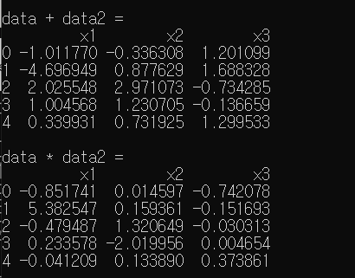

In[36]

Code:

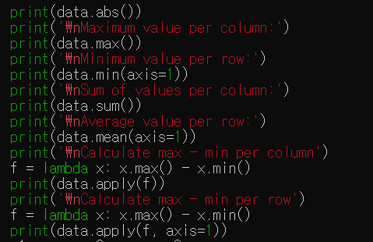

Result:

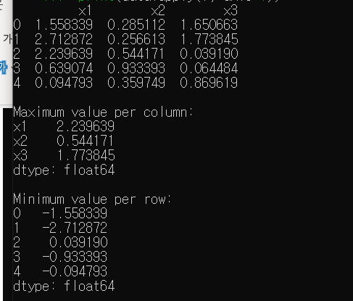

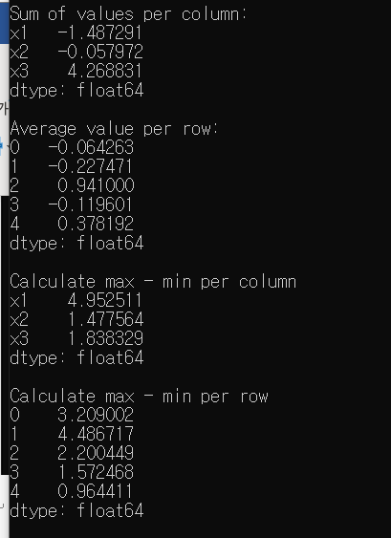

**2.2.4 Plotting Series and DataFrame**

In[37]

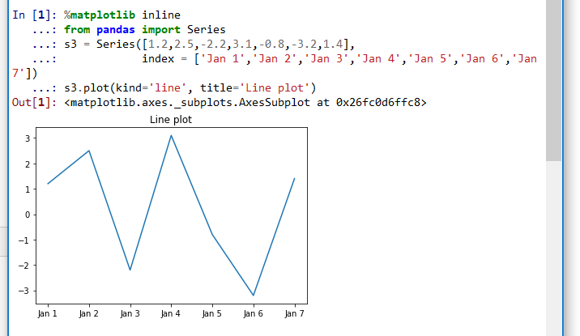

In[38]

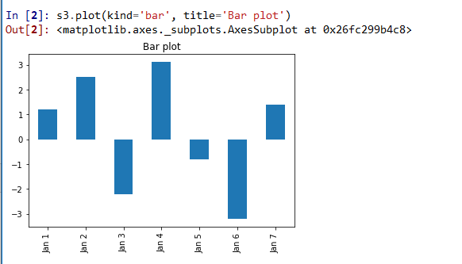

In[39]

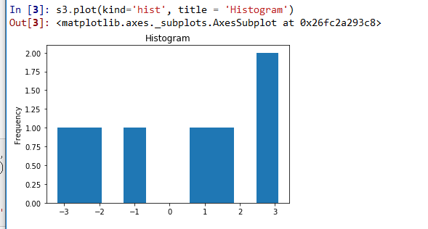

In[40]

